ITRG Data Replication
Author: SAP B1 TECH TEAM - 10 Jan 2017
Version 1.0

Introduction
The entities in this document refer to the company databases to be setup in SAP Business One. The setup will be done in the Source Entity.
Replication will be triggered from the Source entity to Target entity.
ITRG requires the following master data to be replicated:
- Exchange rate (Singapore Entities)
- Chart of Accounts
- Item Code
- Supplier Master
- Supplier Price List
- BoM (Recipes)

ITRG Replication – General Setup
Each entity (Source Database) will have a setup table to indicate the Target database to copy the master data from. When master data is being created or updated in the source database, the entity will be updated with the delta changes automatically with human intervention.
Deletion will not be replicated. This is because an item can be created in the source database and replicated to the target databases. This item may not be used in the source database, but may have been used in the target databases. Hence any automatic deletion replication may be fail in the target database. If the user recreates the deleted item with a different purpose, this may conflict with the item transaction that failed to be deleted in the target database.

The Data Replication process flow as below:
Source Entity

Transaction Notification
Start
Item Master Data
Finance
Business Partner Master Data

Replication Setup

Integration database – Temp Table insert data
Replication Process - UI
Success
Sync Status will be updated as Failure
Sync Status will be updated as Success

Fresh/Failure transactions

NO
YES

YES
Target Entity
Replication completed in target database
End

Process Flow Explanation:
- The data replication process flow begins in master data replication setup in source database.
- If any Master data’s are created or updated in the source entity; these details will be captured in the integration database for replication.
- Replication process will fetch the transaction from temp table from integration database; it will be either fresh transaction or failure transactions.
- Replication process will trigger to the target entities based on the setup.
- If Replication process is successful then success flag will be updated in both Replication table and temp table against the each transaction.
- If Replication is unsuccessful due to some reason then failure flag will be updated in both Replication table and temp table against the each transaction.
- Success flag entries will not come to replication queue again.
- Later failure flag entries need to review and rectify, then again failure entries will go for replication.
- The Same process will repeat as mentioned above.
- The Same process will be followed by all the three master replications.

1. Replication Setup:
There are three types of master data replication setup’s we need to configure based on the target entity.
1. BP Master data replication setup.
2. Finance Master data replication setup.
3. Item Master data replication setup.

1.1 BP Master Data Replication Setup:
Find the below screen shot, how to setup the BP Master replication.
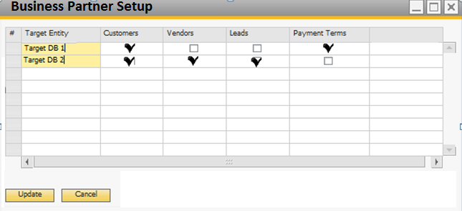

1. Select the ‘Target Entity/Database” in target entity column and define what are the replication process we need to do for that target entity. Target Entity is selection option and target entities will be filled from the target entity credential table.
2. See the Example of the above screen shot, in the target Entity/Database “Target DB 1” , we need to replicate the “payment terms” and “customers”.
3. In the target entity/Database “Target DB 2”, we need to replicate the “Customers”, “vendors” and “Leads” only.
4. Customers and Vendors will be managed by unique Business Partner (BP) groups.
5. Assumptions & Error Handling:
  - The customer and vendor code in the target entity should be the same as the source entity.
  - Users should not manually create in the target entities or when they manually create, they should choose a standard format that will not conflict with the BP codes to be replicated.
  - In the event that BP code already exists in the target entity and cannot be amended due to existing transactions, users will need to amend the BP code in the source entity.
  - Users should only start transacting using the new BP code when the intended replication is successful across all target entities.

1.2 Finance Master Data Replication Setup:
Find the following screen shot, how to setup the Finance Master Data replication.
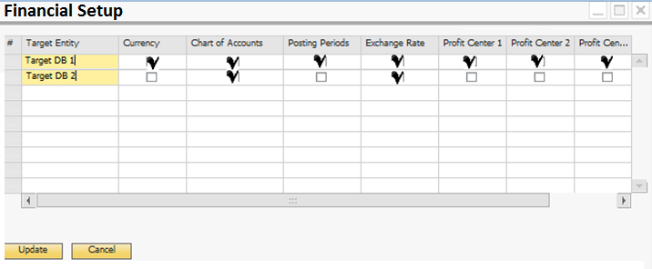

1. Select the ‘Target Entity” in the target entity column and define what are the replication we need to do for that target entity. Target Entity is selection option and target entities will be filled from the target entity credential table.
2. See the Example of the above screen shot, in the target Entity/Database “Target DB 1” , we need to replicate the “curreny”, “COA”, “Posting Periods”, “Exchange rates” and “all five profit center codes”.
3. In the target entity/Database “Target DB 2”, we need to replicate “COA” and “Exchange rates” only.
4. Currency Code and Chart of Accounts can be replicated or updated if already exists.
5. Posting Period can be replicated if the starting date of the next fiscal period in the target entity is the same as the source entity.
6. The exchange rates can be replicated from the source to the target entity if the following conditions apply:
- The currency code (e.g. USD, GBP) exists in both source and target entities.
- The local and system currency of the source entity is the same as the local and system currency of the target entity.
- The exchange rate representation in local terms (indirect or direct) must be the same in both source and target entities.
7. If the dimension level (1 to 5) is activated in both the source and target entities, new profit center’s can be replicated. Changes in the profit centres such as effective dates will not be replicated.
1.3 Item Master Data Replication Setup:
Find the following screen shot, how to setup the Item Master Data replication.
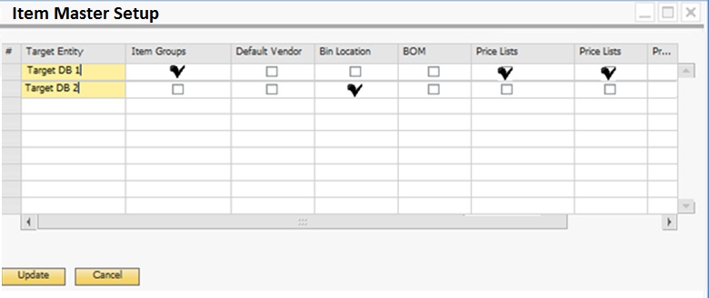

1. Select the ‘Target Entity” in the target entity column and define what are the replications we need to do for that target entity. Target Entity is selection option and target entities will be filled from the target entity credential table.
2. See the Example of the above screen shot, in the target Entity/Database “Target DB 1” , we need to replicate the “Item Groups” and “Price Lists”.
3. In the target entity/Database “Target DB 2”, we need to replicate the “BOM” only.
4. Item master data will be managed by unique Item groups.
5. By default, item groups will not be replicated unless the “Replicate Item Group” is ticked.
** Item Group Name will be the key instead of Item Group Code.
Hence users must not overwrite and amend the item group name without understanding the impact of the changes.
6. Warehouse (outlet) will not be replicated because warehouse (outlet) code must be unique across the ITRG landscape.
7. Some common stock locations (bin location) within each warehouse (outlet) can be replicated, for example “TRANSFER”, “NON-FOOD” and “STORE”. By default, the bin locations will not be replicated to every warehouse unless the “Replicate Bin Locations” is ticked. Bin locations in the inclusion list will be replicated.
8. By default, Price Lists (Outlet Manager Customized Price Lists by Business Partner by UoM) will not be replicated unless the “Replicate by Business Partner by UoM” is ticked.
1.4 Integration Database – Temporary Table:
Whenever the master data’s are adding or updating in the source databases/entities, the data will be inserted/updated into the integration database for replication.
Find the below screen shot, how the data will be stored in the integration database when adding or updating in source databases.
Master Type | Unique ID | Trans Type | Code | Name | Sync Status | Sync  Date | Error Message
BP Master | 1000 | Customer | C00001 | ABC and CO | NO
BP Master | 1001 | Vendor | V00001 | XYZ and CO | NO
BP Master | 1002 | Lead | L00001 | TATA | NO
BP Master | 1003 | Customer | C00001 | ABC and CO | NO
BP Master | 1004 | Payment | CASH | CASH | NO
BP Master | 1005 | Payment | 30 Days from Invoice | 30 Days from Invoice | NO
BP Master | 1006 | BP Group | Domestic Customers | Domestic Customers | NO
Finance | 1007 | COA | 12000021 | Expense Account | NO
Finance | 1008 | COA | 12000022 | Revenue Account | NO
Finance | 1009 | Currency | INR | Indian Currency | NO
Finance | 1010 | Cost Centre | Profit1 | Profit1 | NO
Finance | 1011 | Cost Centre | Profit2 | Profit2 | NO
Item Master | 1012 | Items | Item0001 | Item Code 1
Item Master | 1013 | Items | Item0002 | Item Code 2
Item Master | 1014 | BOM | Item0001 | Item Code 1
Item Master | 1015 | Item Group | Consumables | Consumables
Item Master | 1016 | Item Group | Finished Goods | Finished Goods
Item Master | 1017 | Price List | Price List New | Price List New
Integration Table Properties:
- “Master type” column will indicate that what type of master data transaction is stored.
- “Unique ID” is the auto incrementing code, which is help us to filter the data while replication. It will be unique values.
- “Tran’s type” will indicate that what type of transaction is added or updated.
- “Code and Name” will store the basic information of the transaction.
- “Sync Status” will indicate about the status of replication, whether replication is success or failure. These details will be updated once the replication process is completed.
- “Sync Date” is the date and time of the replication process, it will update automatically.
- “Sync Message” column will be updated the reason failure, if replication gets any error.

2. Replication Process:
Replication process will trigger from the source entity by Master data replication screen, find the below screen shot. Find the below replication for business partner master data.
Find the below, replication process for Financial master data.
2.2 Master Data Replication screen Properties:
- In header, we have to select the “master data type”.
- After selected “master data type”, the data will be fetched from the integration table and it will upload in the table.
- See the above screen, data being filled based on the selection.
- Just select the transaction that whichever transaction you want to replicate.
- Once replication process is completed then the success/unsuccessful flag and date will be updated in the sync status and sync date accordingly, also the same sync status flag and date will be updated in the temp table in integration Database.
- During the replication process if any transaction is not successful for all the target entities (2 entity success and 1 entity failure) then the same transaction will be considered as failure.
- Once replication is successful for target entities, the same transaction will not trigger again for the replication queue.
- Based on the sync status the transaction will be filtered.
- For Financial master data filtration, there are two check will be enabled for replication such as “Posting periods” and “Exchange Rates”.
- These two check boxes will be invisible for remaining two master data replications.
- Replication process transaction details will not be saved anywhere instead the replication status will be updated in the integration table.

2.3 Find the below screen shot, after the replication process.

- After completed the replication process, the status will be updated to the sync status column.
- See the above screen shot; there are two transaction replications are unsuccessful due to some reason. This is update as failure flag in sync status column.
- The date of replication will be updated in the sync date column.
- Once sync status became success then the same entry will not replicate again for the same target entity.
- The same process will be followed to other two types of master data replications.

Find the below screen shot, to explain how temp table will update after the replication process.
Master Type | Unique ID | Trans Type | Code | Name | Sync Status | Sync  Date | Error Message
BP Master | 1000 | Customer | C00001 | ABC and CO | YES | 2017-01-10 17:16:05.970
BP Master | 1001 | Vendor | V00001 | XYZ and CO | YES | 2017-01-10 17:16:05.970
BP Master | 1002 | Lead | L00001 | TATA | YES | 2017-01-10 17:16:05.970
BP Master | 1003 | Customer | C00001 | ABC and CO | YES | 2017-01-10 17:16:05.970
BP Master | 1004 | Payment | CASH | CASH | NO | 2017-01-10 17:16:05.970 | No Access
BP Master | 1005 | Payment | 30 Days from Invoice | 30 Days from Invoice | NO | 2017-01-10 17:16:05.970 | No Access
BP Master | 1006 | BP Group | Domestic Customers | Domestic Customers | YES | 2017-01-10 17:16:05.970

3. Transaction Replication

3.1 Create UDT in Source db (outlet)
Target Entity Credentials Setting
Source BP | Target DB | Target Branch | Target BP | Target WH | Target Bin | User Name | Password
V10001 | HQ | Br001 | C10001 | WH1 | WH1-CCS-01 | Manager | 1234

Properties
- Source BP column is a setup where the BP needs to create the intercompany transaction.
- Target DB column will indicate that the intercompany transaction to create in which database.
- User name and password are the detail credentials of the target company.
- Target branch column is a setup to use as a default branch in the target database.
- Target BP column is a setup to use as a default BP in the target database.
- Target warehouse column is a setup to use as a default warehouse in the target database.
- Target bin location column is a setup to use as a default bin location in the target database.

3.2 Create UDF in Marketing Document (Header)
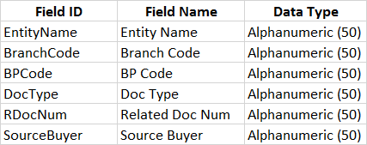

3.3 Replication Process
PO to SO

- Purchase Order will be generated by the user. (Refer to Image 1 below)
- Once Sales Order is created in the target database, system will update the “Target DB” in the “Entity Name”, “Target Branch” in the “Branch Code”, “Target BP” in the “BP Code”, “Target Object Type” in “Doc Type”, and the Target Doc Num (SO number) in the “Related Doc Num” field.

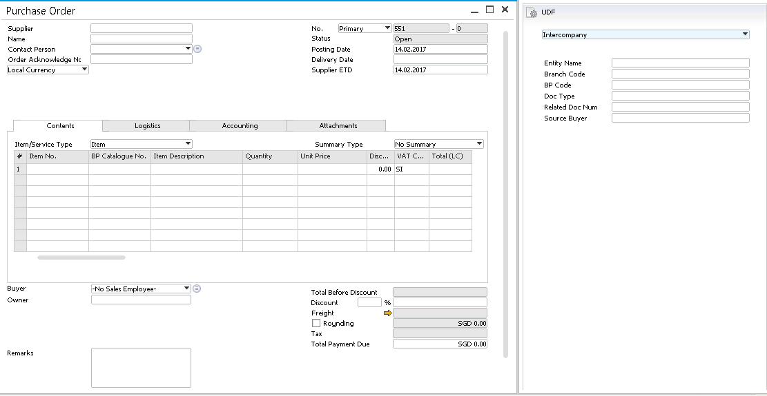
a

Image 1

- Upon creation of a PO, Sales Order will be auto created with Source DB (Entity Name), Source Branch (Branch Code), Source BP (BP Code), “Source Object Type” in “Doc Type”, Related Doc Num (PO number) and source buyer (OPOR.SlpCode) in the target database. (Refer to Image 2 below)
- Please refer to the UDT table for Customer Code, Branch Code (if applicable), Warehouse Code, and Bin Location (if applicable).
- Do no need Branch Code and Bin Location if Pricing Method (UDT) is “Price List”. Because this is for Ranking Sport.
- Sales employee in PO will flow over to Source Buyer UDF in Sales Order.

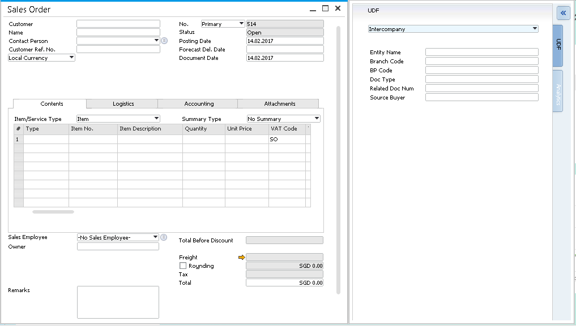
Image 2

- In the case of failure, user needs to update the Purchase Order to replicate.

DO to GRPO

- User will convert manually the Sales Order to Delivery Order.
- Upon creation of a Delivery Order, GRPO will be auto created with Source DB (Entity Name), Source Branch (Branch Code), Source BP (BP Code), “Source Object Type” in “Doc Type”, and Related Doc Num (DO number) in the target database by copying from based document. (Refer to Image 3 below)
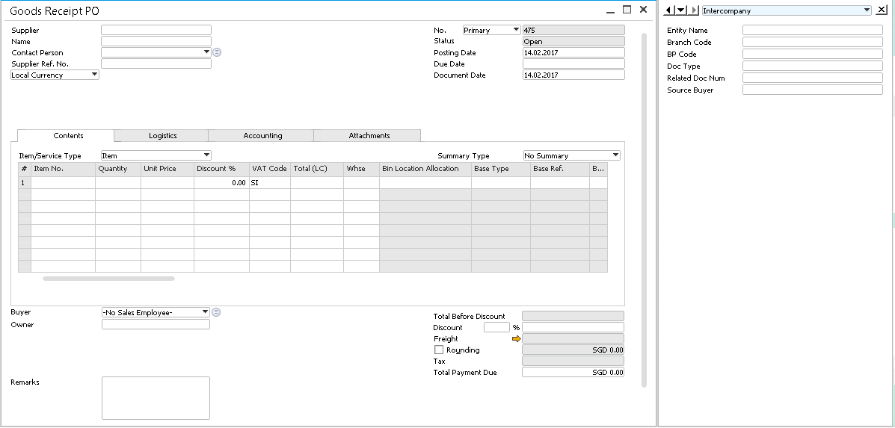
Image 3

- While creating GRPO, system will check “Pricing Method” UDT for GRPO price.
If Pricing Method = ‘Cost to Cost’ then take the price from DO line item cost.
If Pricing Method = ‘Price list’ then copy the price from based PO.

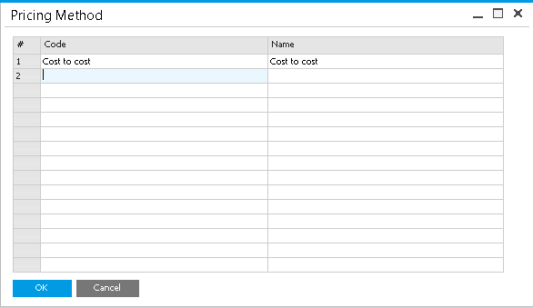

- Once GRPO is created, the program will update to the source DO for the Target DB (Entity Name), Target Branch (Branch Code), Target BP (BP Code), “Target Object Type” in “Doc Type”, and Related Doc Num (GRPO number). (Refer to Image 4 below)
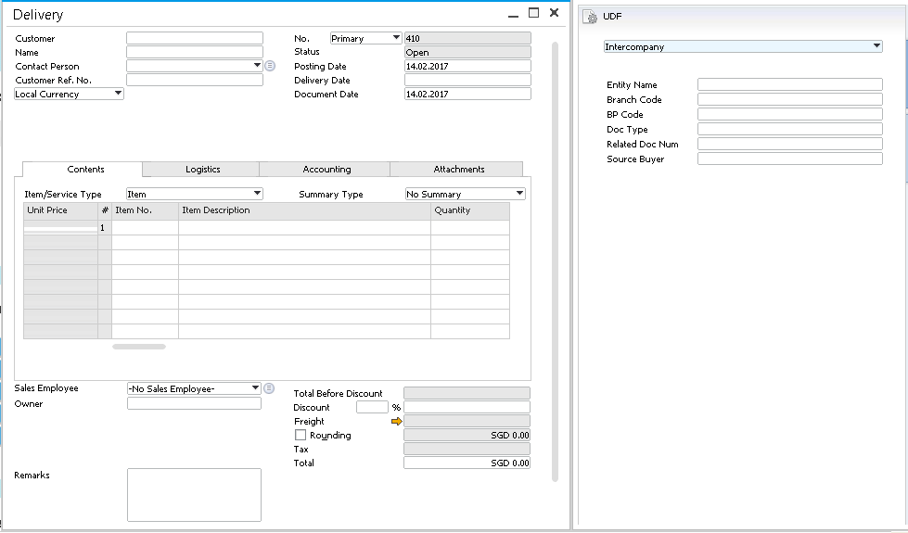

- In the case of failure, user needs to update the Delivery Order to replicate.

Transaction Notification
- Users are not allowed to create the AR Invoice in the source company until the GRPO is created in the receiver company for the purpose of relationship map. So create TN to block AR Invoice if GRPO is not yet created.

AR Invoice to AP Invoice
- User will convert manually the Delivery Order to AR Invoice
- Upon creation of an AR Invoice, AP Invoice will be auto created with Source DB (Entity Name), Source Branch (Branch Code), Source BP (BP Code), “Source Object Type” in “Doc Type”, and Related Doc Num (AR Invoice number) in the target database by copying from the based document. (Refer to Image 5 below)
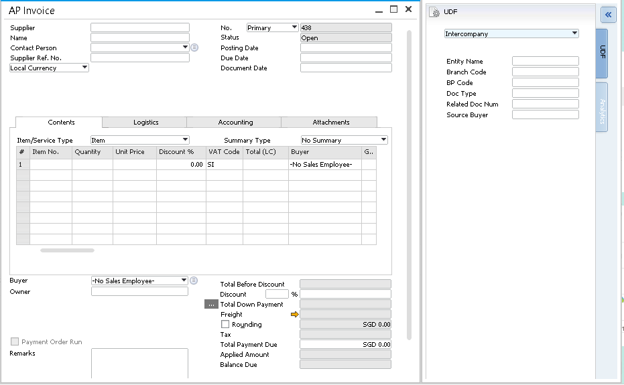
Image 5

- Once AP Invoice is created, the program will update to the source AR Invoice for the Target DB (Entity Name), Target Branch (Branch Code), Target BP (BP Code), “Target Object Type” in “Doc Type”, and Related Doc Num (AP Invoice number). (Refer to Image 6 below)
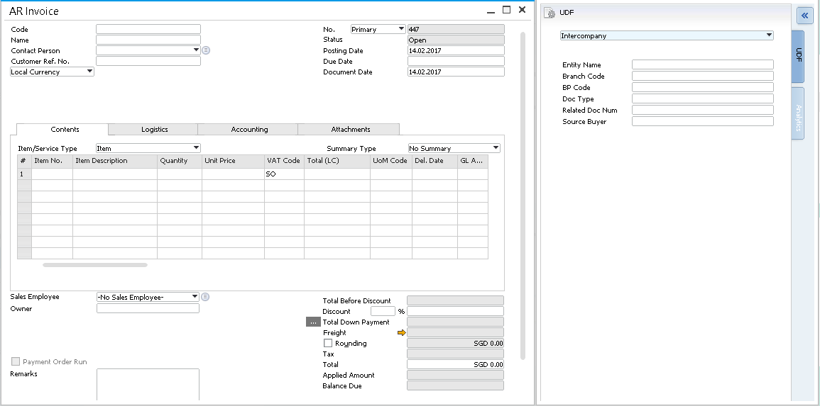
Image 6

- In the case of failure, user needs to update the AR Invoice to replicate.

3.4 Integration Database – Temporary Table:
Whenever the transactions are adding or updating in the source databases/entities, the data will be inserted/updated into the integration database as a log file.
Find the below screen shot, how the data will be stored in the integration database when adding or updating in source databases.

4. Intercompany Payments
4.1 Outlet transfer sales collection to HQ

AP Invoice to AR Invoice

- User will manually create the AP Invoice in outlet.
- If supplier code is ITRG Holdings in AP Invoice, AR Invoice will be auto created in Holding Database with Source DB (Entity Name), Source Branch (Branch Code), Source BP (BP Code), “Source Object Type” in “Doc Type”, and Related Doc Num (AP Invoice number) in the target database. (Refer to Image 7 below)

Image 7

- Once AR Invoice is created, the program will update to the source AP Invoice for the Target DB (Entity Name), Target Branch (Branch Code), Target BP (BP Code), “Target Object Type” in “Doc Type”, and Related Doc Num (AR Invoice number). (Refer to Image 8 below)
Image 8

Outgoing Payment to Incoming Payment
- Outlet will make payment to supplier to transfer sales collection.
- Incoming payment will be auto created in Holding with Source DB (Entity Name), Source Branch (Branch Code), Source BP (BP Code), “Source Object Type” in “Doc Type”, and Related Doc Num (Outgoing payment number) in the target database by copying from the based document. (Refer to Image 9 below)

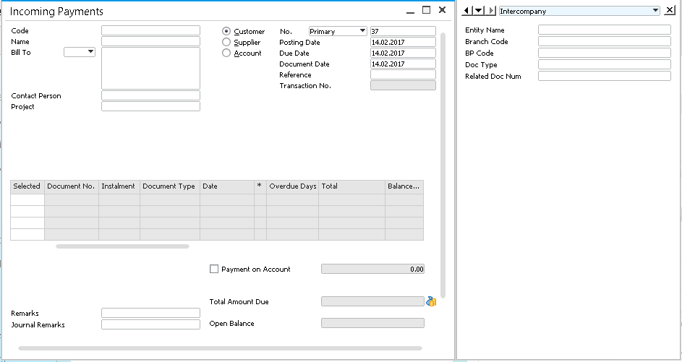
Image9
- Payment type (Bank Transfer/Cash/Cheque/Credit Card) will be the same as the source database. Please refer to below UDT table for gl account in payment means.
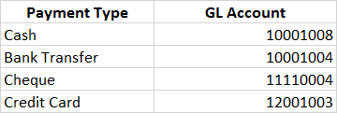

- Once Incoming Payment is created, the program will update to the source Outgoing Payment for the Target DB (Entity Name), Target Branch (Branch Code), Target BP (BP Code), “Target Object Type” in “Doc Type”, and Related Doc Num (Incoming Payment number). (Refer to Image 10 below)
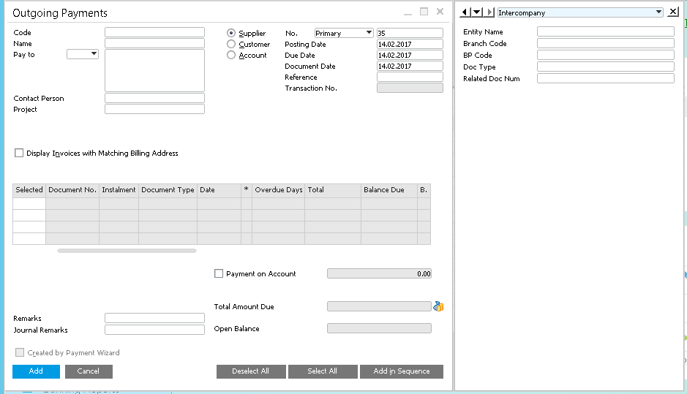
Image 10

4.2 Outlet billed to HQ on behalf of actual supplier

AR Invoice to AP Invoice

- Outlet will receive AP Invoice from supplier
- If payment terms is HQ-30Days/HQ-60Days in supplier’s AP Invoice, AR Invoice (Draft) will be auto created in outlet with Source DB (Entity Name), Source Branch (Branch Code), Source BP (BP Code), “Source Object Type” in “Doc Type”, and Related Doc Num (AP Invoice number) to claim on behalf of actual supplier.
- AP Invoice will be auto created in Holding with Source DB (Entity Name), Source Branch (Branch Code), Source BP (BP Code), and Related Doc Num (AR Invoice number) in the target database. (Refer to Image 11 below)
Image 11

- Once AP Invoice is created, the program will update to the source AR Invoice for the Target DB (Entity Name), Target Branch (Branch Code), Target BP (BP Code), “Target Object Type” in “Doc Type”, and Related Doc Num (AP Invoice number). (Refer to Image 8 below)
Image 12
- Finance will manually reconcile the sales and collection received from the outlet.

5. Mapping Table

PO to SO
ORDR.CardCode | Trigger UDT  (Target Entity Credentials Setting) | Card Code
ORDR.CardName | Auto populate based on selected BP | Card Name
ORDR.CntctCode | Auto populate based on selected BP | Contact Person
ORDR.NumAtCard | OPOR.NumAtCard | Customer/Vendor Ref Number
ORDR.DocDate | OPOR.DocDate | Posting Date
ORDR.DocDueDate | OPOR.DocDueDate | Delivery Date
ORDR.TaxDate | OPOR.TaxDate | Document Date
ORDR.DocType | OPOR.DocType | Document Type (Item/Service)
ORDR.SlpCode | Auto populate based on selected BP | Sales Employee Name
ORDR.Comments | OPOR.Comments | Document Remark
ORDR.U_SourceBuyer | OPOR.SlpCode | Buyer
ORDR.U_EntityName | OPOR.U_EntityName | Database Name
ORDR.U_BranchName | OPOR.U_BranchName | Branch Name
ORDR.U_BPCode | OPOR.U_BPCode | BP Code
ORDR.U_DocType | OPOR.U_DocType | Object Type (SO/DO/AR Inv)
ORDR.U_RDocNum | OPOR.U_RDocNum | Related Document Number

Detail Table
Target Field ID | Source Field ID | Description
RDR1.Type | POR1.Type | Line Item Type (Regular/Text)
RDR1.ItemCode | POR1.ItemCode | Item Code
RDR1.Dscription | POR1.Dscription | Item Description
RDR1.Quantity | POR1.Quantity | Quantity
RDR1.Price | Take from the price list | Unit Price
RDR1.WhseCode | Trigger UDT  (Target Entity Credentials Setting) | Warehouse Code
 | Trigger UDT  (Target Entity Credentials Setting) | Bin Location

DO to GRPO
Header Table
Target Field ID | Source Field ID | Description
OPDN.CardCode | Copy from based document PO | Card Code
OPDN.CardName | Copy from based document PO | Card Name
OPDN.CntctCode | Copy from based document PO | Contact Person
OPDN.NumAtCard | Copy from based document PO | Customer/Vendor Ref Number
OPDN.DocDate | ODLN.DocDate | Posting Date
OPDN.DocDueDate | ODLN.DocDueDate | Delivery Date
OPDN.TaxDate | ODLN.TaxDate | Document Date
OPDN.DocType | ODLN.DocType | Document Type (Item/Service)
OPDN.SlpCode | Copy from based document PO | Sales Employee Name
OPDN.Comments | ODLN.Comments | Document Remark
OPDN.U_SourceBuyer | Copy from based document PO | Buyer
OPDN.U_EntityName | ODLN.U_EntityName | Database Name
OPDN.U_BranchName | ODLN.U_BranchName | Branch Name
OPDN.U_BPCode | ODLN.U_BPCode | BP Code
OPDN.U_DocType | ODLN.U_DocType | Object Type (SO/DO/AR Inv)
OPDN.U_RDocNum | ODLN.U_RDocNum | Related Document Number

Detail Table
Target Field ID | Source Field ID | Description
PDN1.Type | DLN1.Type | Line Item Type (Regular/Text)
PDN1.ItemCode | DLN1.ItemCode | Item Code
PDN1.Dscription | DLN1.Dscription | Item Description
PDN1.Quantity | DLN1.Quantity | Quantity
PDN1.Price | Check 'Pricing Method' UDT table for price | Unit Price
PDN1.WhseCode | Copy from based document PO line | Warehouse Code
 | Copy from based document PO line | Bin Location

AR to AP
Header Table
Target Field ID | Source Field ID | Description
OPCH.CardCode | Copy from based document GRPO | Card Code
OPCH.CardName | Copy from based document GRPO | Card Name
OPCH.CntctCode | Copy from based document GRPO | Contact Person
OPCH.NumAtCard | Copy from based document GRPO | Customer/Vendor Ref Number
OPCH.DocDate | OINV.DocDate | Posting Date
OPCH.DocDueDate | OINV.DocDueDate | Delivery Date
OPCH.TaxDate | OINV.TaxDate | Document Date
OPCH.DocType | OINV.DocType | Document Type (Item/Service)
OPCH.SlpCode | Copy from based document GRPO | Sales Employee Name
OPCH.Comments | OINV.Comments | Document Remark
OPCH.U_SourceBuyer | Copy from based document GRPO | Buyer
OPCH.U_EntityName | OINV.U_EntityName | Database Name
OPCH.U_BranchName | OINV.U_BranchName | Branch Name
OPCH.U_BPCode | OINV.U_BPCode | BP Code
OPCH.U_DocType | OINV.U_DocType | Object Type (SO/DO/AR Inv)
OPCH.U_RDocNum | OINV.U_RDocNum | Related Document Number

Detail Table
Target Field ID | Source Field ID | Description
PCH1.Type | INV1.Type | Line Item Type (Regular/Text)
PCH1.ItemCode | INV1.ItemCode | Item Code
PCH1.Dscription | INV1.Dscription | Item Description
PCH1.Quantity | INV1.Quantity | Quantity
PCH1.Price | Copy from based document GRPO line | Unit Price
PCH1.WhseCode | Copy from based document GRPO line | Warehouse Code
 | Copy from based document GRPO line | Bin Location

Outgoing Payment to Incoming Payment
Header Table
Target Field ID | Source Field ID | Description
ORCT.CardCode | Copy from based document AR Inv | Card Code
ORCT.CardName | Copy from based document AR Inv | Card Name
ORCT.CntctCode | Copy from based document AR Inv | Contact Person
ORCT.CounterRef | OVPM.CounterRef | Customer/Vendor Ref Number
ORCT.DocDate | OVPM.DocDate | Posting Date
ORCT.DocDueDate | OVPM.DocDueDate | Delivery Date
ORCT.TaxDate | OVPM.TaxDate | Document Date
ORCT.DocType | Customer | Document Type (Customer/Supplier)
OPCH.Comments | OVPM.Comments | Document Remark
ORCT.JrnlMemo | OVPM.JrnlMemo
ORCT.NoDocSum | OVPM.NoDocSum | Payment on Account
ORCT.U_EntityName | OVPM.U_EntityName | Database Name
ORCT.U_BranchName | OVPM.U_BranchName | Branch Name
ORCT.U_BPCode | OVPM.U_BPCode | BP Code
ORCT.U_DocType | OVPM.U_DocType | Object Type (SO/DO/AR Inv)
ORCT.U_RDocNum | OVPM.U_RDocNum | Related Document Number

6. Target Entity Credentials Setting:
We need to capture the Target entity credentials for connecting the entity/database while posting from source entity to target entity.
This configuration details will be captured in the Source Database.
The following screen, indicating that what are the informations we need capture against the target entities.
Entity Name | Username | Password
Branch_DB1 | Manager | 1234
Branch_DB2 | Manager | 5674

Thank you

